UNIT-III

APPLICATIONS OF OPAMP

PART-A

- List any four important application of comparator.(Apr/May-2018)
The applications of comparator are:
    - Zero crossing detector
    - Window detector
    - Time marker generator
    - Phase meter.
.

- Draw the circuit of antilog OP-AMP amplifier?(Nov/Dec-2019)
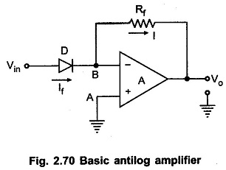
- Draw a sample and hold circuit. (AU-Nov/Dec-2018)

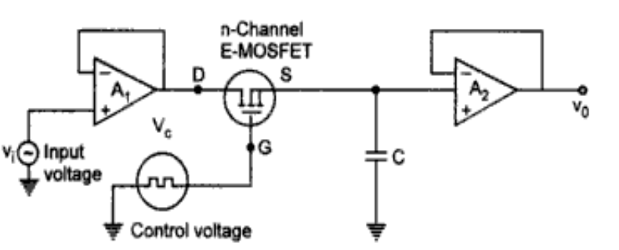

- Which is the fastest ADC and why?(April/May- 2019)

- The parallel comparator (or) Flash type ADC is the fastest technique because the conversion takes place simultaneously rather than sequentially. Typical conversion time is 100 ns or less.

- What is a Schmitt trigger? (Nov/Dec 2018)

Schmitt trigger is a regenerative comparator. It converts sinusoidal input into a square wave output. The output of Schmitt trigger swings between upper and lower threshold voltages,which are the reference voltages of the input waveform.

  - Draw the circuit diagram of Zero crossing detector with input and output waveforms.(Apr/may 2019,2017)
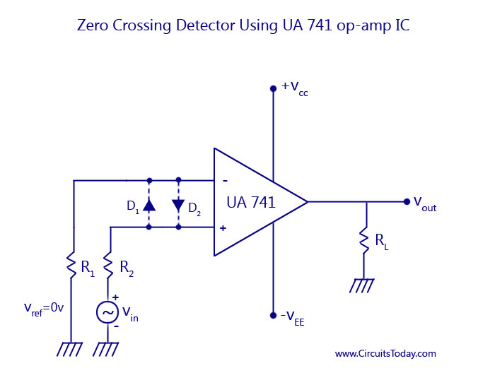
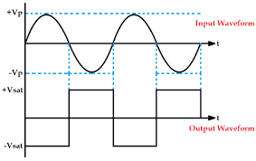

7. What is an astable multivibrator?(Nov/Dec-2019)

Astable multivibrator is a free running oscillator having two quasi-stable states. Thus,there are oscillations between these two states and no external signal is required to produce the change in state.

8. What is a Sample and Hold Circuit? (April/May-2018) (Nov/Dec-2019)

- A sample and hold (S/H, also "follow-and-hold") circuit is an analog device that samples (captures, grabs) the voltage of a continuously varying analog signal and holds (locks, freezes) its value at a constant level for a specified minimum period of time.
- The primary use of the sample and hold circuit is to hold the sample analog input voltage constant during conversion time of A/D converter. It also reduces the cross talk in the multiplexer.

9. What are the applications of comparator?(Apr/May 2018)

a. Zero crossing detector b. Window detector
c. Time marker generator d. Phase detector

- Draw the circuit diagram of log amplifier using two opamps. (Nov /Dec 2015)

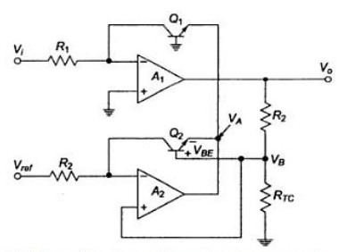

- Write any two applications of clippers and clampers.?(Nov/Dec 2017)
They are frequently used for the separation of synchronizing signals from the composite picture signals.
Clippers can be used as voltage limiters and amplitude selectors.
These are frequently used in test equipment, sonar and radar systems.
Clampers can be used as voltage doublers or voltage multipliers

- Why is the monostable multivibrator called time delay circuit or gating circuit?

Monostable multivibrator is called Time Delay circuit because it generates a fast transition at a predetermined time T after the application of input trigger.

T = 0.69 RC

It is also called as Gating circuit because it generates pulses (or) rectangular waveform at definite desired time duration

- What is one-shot multivibrator?

The monostable is also called as one-shot multivibrator as it produces a single pulse of specified duration in response to each external trigger signal. Only one stable state exists. When an external trigger signal is applied the output changes its state. The new state is called quasi-stable state.

- What is the difference between a Saw tooth and triangular wave?
The difference between the triangular and saw tooth waveforms is that the rise time of the triangular waveforms is always equal to its fall time where as the Saw tooth waveform has unequal rise and fall times.

- Give applications of a sample and hold circuit.

    - Digital interfacing

    - Analog to Digital converters

    - Pulse Code Modulation systems

- What is DAC?

A Digital to Analog converter is used to convert a digital signal to an analog signal. Hence the input is an n-bit binary word D and is combined with a reference voltage V_{R} to give an analog output signal. The output of a DAC is either voltage or current.
- What is ADC?

An ADC circuit accepts as analog input voltage V_{a} and produces an output d₁,d₂,…,d_{n} of functional value D, so that

D = d₁ 2 ⁻ ¹ + d₂ 2⁻ ² +…….. + d_{n} 2^{- n}

Where, d₁ is the Most Significant Bit (MSB)

d_{n} is the Least Significant Bit (LSB)

- . List the various ADC techniques.

ADC’s are broadly classified into two types

- Direct Type ADC’s

  - Flash type converter

  - Counter type converter

  - Tracking or Servo type converter

  - Successive approximation type ADC

- Integrating Type ADC’s

      - Charge balancing type converter

      - Single slope converter

      - Dual slope converter

- List out the advantages of sample and hold circuits.

The advantages of sample and hold circuits are

  - It reduces the cross talk in the multiplexer.

In the case of multi channel ADCs, synchronization can be achieved by sampling signals from all channels at the same time.

